PROJECT METHODOLOGY
UAV-Based Human Detection, Multi-Object Tracking, and Pedestrian Attribute Recognition
A multi-observation framework for robust attribute inference from aerial video

August 2026

Abstract
A person filmed from a moving aerial platform is rarely captured clearly in any single frame — but across a short trajectory, at least one view is usually unobstructed, well-lit, and well-posed. This project builds a pedestrian attribute recognition system for UAV footage that detects and tracks individuals, then pools evidence from several observations of the same person before deciding on attributes such as clothing colour, style, and accessories.
A real-time detector locates people in each frame; a lightweight tracker links detections into consistent identities; a transformer-based attribute model extracts diverse features per observation; and a relation-fusion module combines evidence across observations into a single, more reliable prediction. Both the detector and attribute model are adapted to the aerial domain using public UAV datasets and project-collected footage, so the final system is evaluated under its true operating conditions.
The central question: does combining multiple observations of the same identity improve attribute accuracy over a single best frame? This is tested directly through a controlled ablation across observation counts, alongside standard detection and tracking benchmarks.

1. System Overview
The system converts raw UAV video into a structured, per-person attribute record through five stages, each with a single, well-defined responsibility. The output of one stage is the sole input to the next.

1.1 Pipeline
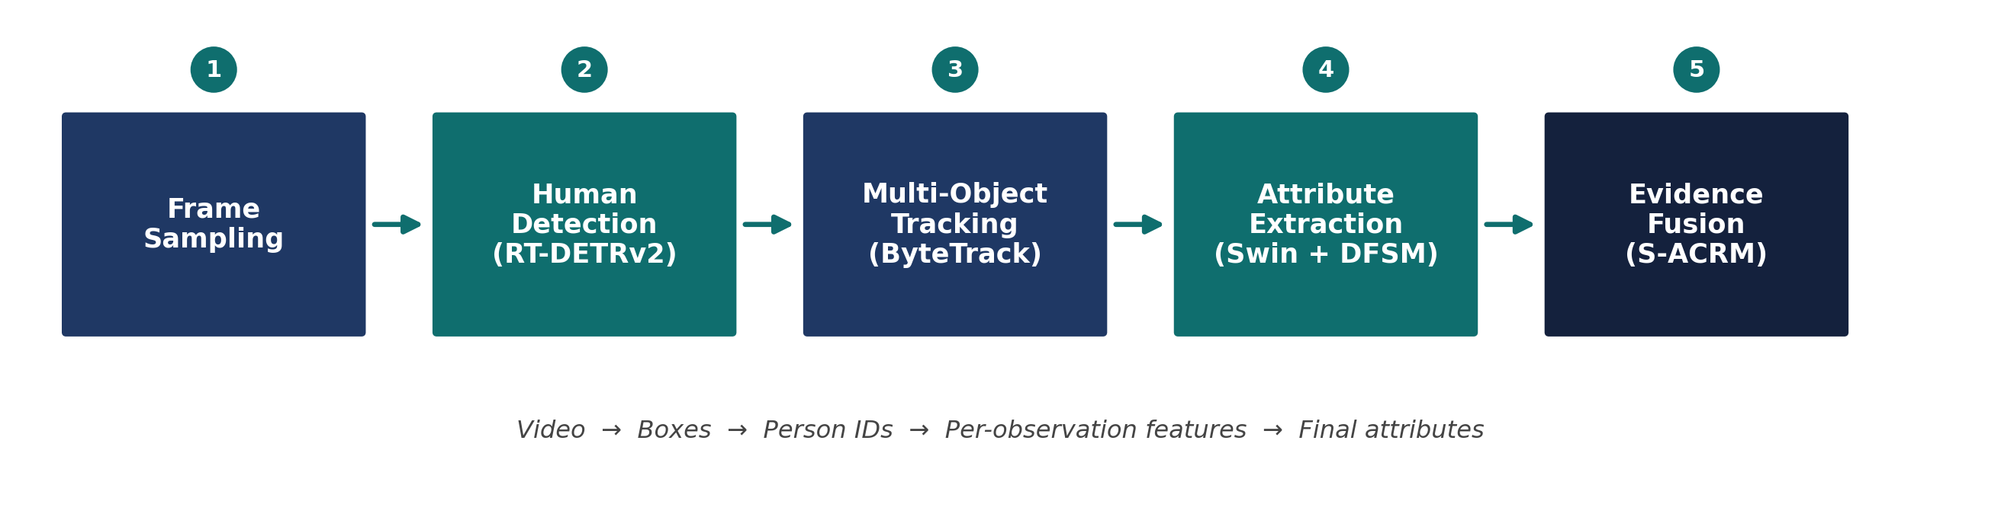
Figure 1. End-to-end pipeline, from raw video to final per-person attributes.
Stage | Component | Responsibility | Output
1 | Frame sampling | Reduce a full video to a manageable, representative frame set | Candidate frame list
2 | Human detector (RT-DETRv2) | Localise every person in a frame | Bounding boxes + confidence
3 | Tracker (ByteTrack) | Link detections across frames into identities | Person ID + trajectory
4 | Attribute backbone (Swin + DFSM) | Extract diverse, complementary features per observation | Feature logits + activation evidence
5 | Relation fusion (S-ACRM) | Combine confidence and activation evidence across observations | Final multi-label attributes

Each stage is independently verifiable: a detector's output is a candidate box, not an attribute label; a tracker's output is an identity, not verified ground truth; a model's automatic prediction is never treated as final annotation without human review.

1.2 Core Hypothesis
Multiple diverse aerial observations of the same individual provide more reliable attribute evidence than a single observation, particularly under occlusion, viewpoint change, and small-object conditions. Section 7 tests this directly by comparing performance as the number of fused observations per identity increases.

2. Datasets
Three categories of data support the project: public aerial-detection benchmarks for general localisation ability, a UAV-specific attribute dataset for pedestrian-attribute supervision, and project-collected drone footage for target-domain adaptation and final evaluation. Public data initialises and pretrains the models; the project's own footage is what the system is ultimately trained and tested to work on.
Dataset | Role in the Project | Priority
VisDrone | Real aerial detection training and validation | Essential — detector
UAV-Human | Aerial-viewpoint pedestrian attributes and person sequences | Essential — attributes
Project drone footage | Target-domain adaptation and final held-out evaluation | Mandatory
PA-100K / PETA / RAPv1-v2 / UPAR | General pedestrian-attribute pretraining and benchmarking | Optional
SkyScenes | Synthetic aerial pretraining (instance masks converted to boxes) | Optional

2.1 Notes on Each Source
- VisDrone: primary human-detection data; pedestrian category mapped to a single target class; video/MOT split used only for an optional supplementary tracking experiment.
- UAV-Human: primary source of aerial-viewpoint attributes and person sequences (gender, headwear, backpack, upper/lower garment colour and style); its drone perspective makes it far more representative than ground-level datasets.
- PA-100K / PETA / RAPv1-v2 / UPAR: used only where they improve pretraining or add a benchmark — PA-100K contributes ~100,000 images across 26 attributes, PETA ~19,000 images of 8,705 individuals; UPAR harmonises attribute definitions across sources where relevant.
- Project drone footage: a held-out portion is reserved for final testing at every stage and never used for training — the only data that matches true deployment conditions.

3. Data Preparation

3.1 Video Audit
Before any extraction or annotation, the source footage (approximately 30 minutes, 16 GB) is audited for the properties that most affect downstream detection quality:
- Frame rate and resolution
- Camera altitude and viewing angle
- Typical on-screen person size
- Motion blur and camera movement
- Lighting and weather variation
- Crowd density and occlusion levels
- Scene changes and repeated backgrounds

3.2 Frame Sampling
At roughly 30 frames per second, the full video contains on the order of 54,000 frames — far more than should be annotated exhaustively. Sampling starts conservatively and expands only where the audit indicates it is necessary:
- Baseline: 1 frame every 2 seconds (~900 frames)
- Fast-changing scenes: 1 frame per second (~1,800 frames)
- Refinement: add rare or difficult cases after visual inspection; remove near-duplicate frames

3.3 Preparation Workflow
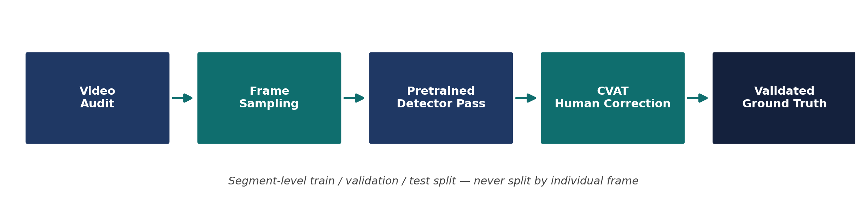
Figure 2. Frame preparation and ground-truth workflow.
The resulting annotation set is split at the video-segment level, never by shuffling individual frames, so adjacent frames of the same scene or person cannot appear in both training and test sets — preventing identity and temporal leakage.

4. Human Detection
RT-DETRv2 is the primary human detector. The pretrained, COCO-trained model is run first to establish a zero-adaptation baseline on the project's own footage, before any aerial-specific fine-tuning is applied.

4.1 Automatic Pre-Annotation and Correction
Predicted boxes are exported to CVAT for human review rather than accepted as ground truth, using a permissive confidence threshold so weak candidates are surfaced for review. During review:
- Missed people are added; false positives are removed
- Inaccurate boxes are tightened or repaired
- Small and overlapping people receive particular attention
- Ambiguous frames are flagged rather than force-labelled
Each detection is recorded with frame ID, class, confidence, and box coordinates. An Ultralytics YOLO model can optionally assist annotation but does not replace RT-DETRv2 in the final system.

4.2 Optional Synthetic Aerial Pretraining
SkyScenes, a synthetic aerial dataset with per-instance annotations, can supply an additional pretraining stage. Its instance masks are converted to boxes:
- Select flight heights, pitches, and weather closest to the project's own footage
- Extract pedestrian instances and compute bounding extents
- Convert to normalised coordinates and verify visually
- Discard invalid, empty, or unusably small instances
Included only if a validation experiment shows measurable improvement over the added preprocessing cost.

4.3 Detector Training Ladder
The detector is trained across a controlled sequence of increasingly adapted variants, all measured on the same held-out test segment, isolating each adaptation step's contribution:
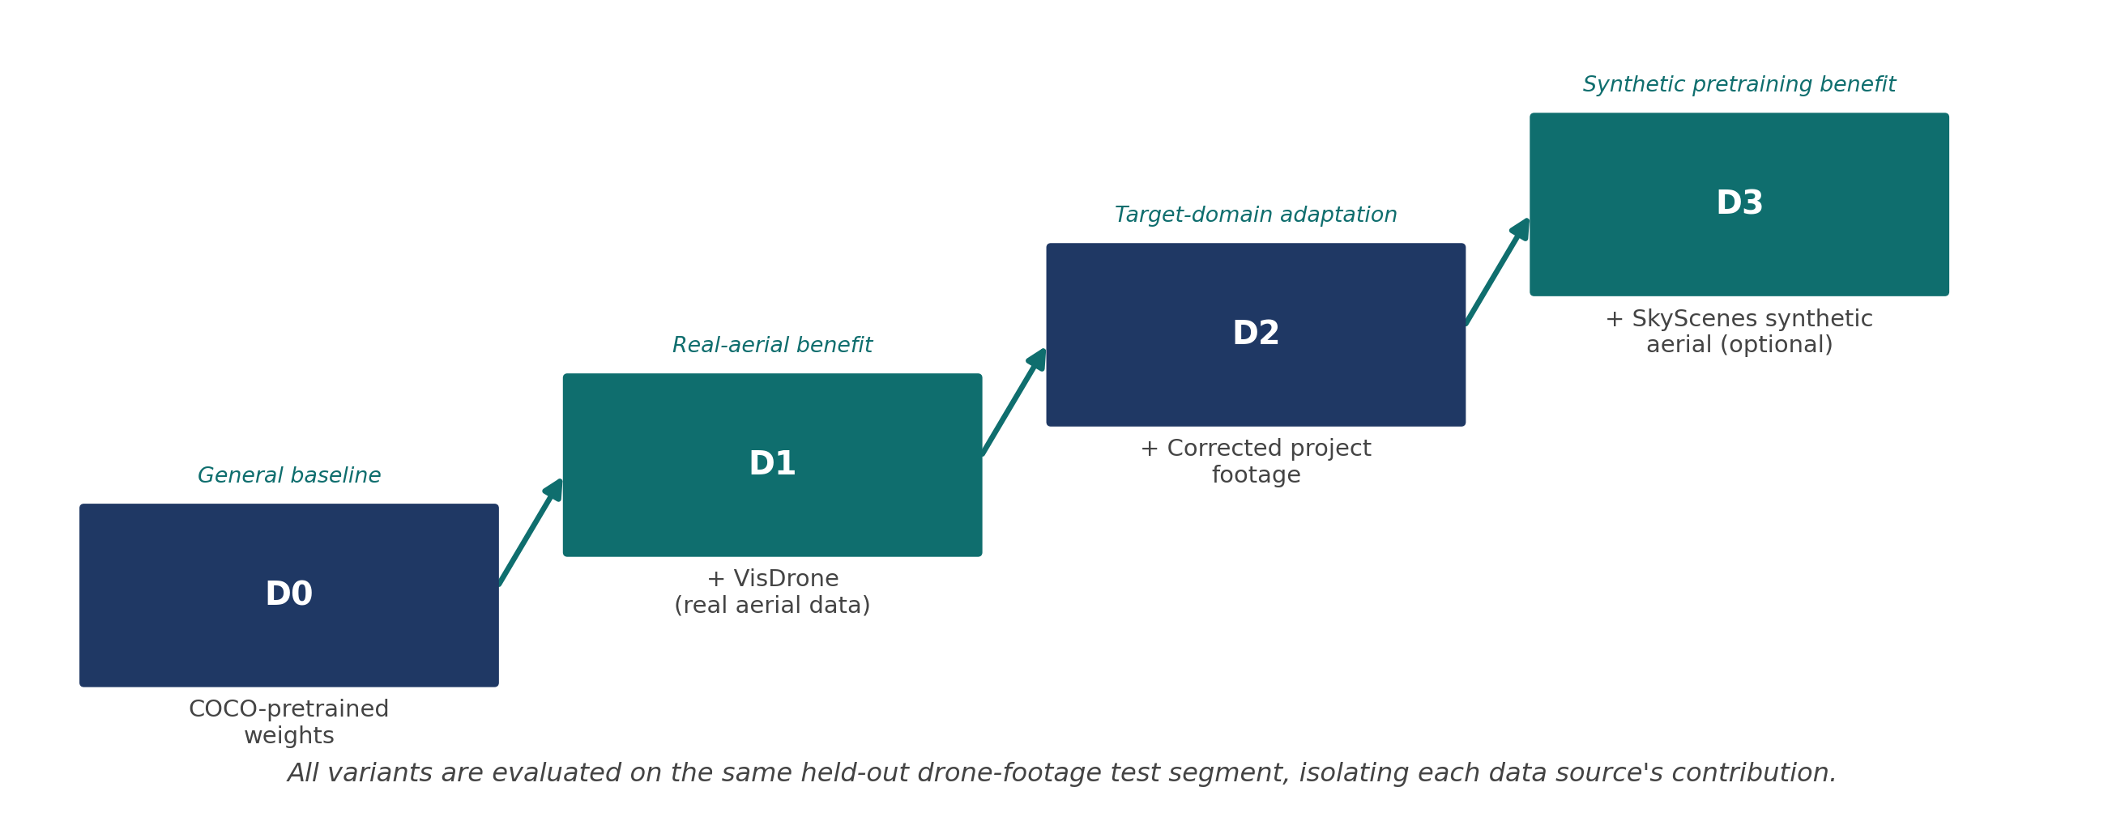
Figure 3. Detector training ladder — each variant builds on the last.
Detection performance is reported as Precision, Recall, mAP@50, mAP@50:95, and FPS, stratified by person size and occlusion where labels permit. A strong D0 baseline is a valid outcome in its own right; the contribution is measured by improvement on aerial, small-object, and occluded cases specifically.

5. Multi-Object Tracking
ByteTrack links per-frame detections into persistent identities, converting a stream of independent boxes into person-level trajectories.

Figure 4. Tracking bridges per-frame detection and multi-observation fusion.
Without a reliable identity linking detections across frames, there is no principled way to know which observations belong to the same person. From each trajectory, a diverse — not merely adjacent — subset of crops is selected, favouring changes in viewpoint, pose, visibility, and lighting, and discarding heavily blurred or duplicate frames.
Tracking quality is evaluated using IDF1, MOTA, and identity-switch count, alongside the detection metrics in Section 4.

6. Pedestrian Attribute Recognition
Attribute recognition proceeds through feature extraction, diverse-feature discovery, and evidence fusion across a person's tracked observations.

6.1 Attribute Set
The attribute set is drawn from UAV-Human, restricted to attributes genuinely visible from a drone's viewpoint. Difficult-to-judge attributes are labelled unknown rather than assumed negative; gender is annotated only where viewpoint and quality support a defensible judgement.
Attribute | Notes
Backpack presence | Binary — clearly visible in most viewpoints
Headwear | Binary — small object, benefits from multi-frame fusion
Upper-garment colour / style | Multi-class
Lower-garment colour / style | Multi-class
Gender | Annotated only where defensible from image quality

Each identity initially receives five to ten representative annotated crops. As with detection, splits are made by identity or video segment, never by frame, to prevent leakage.

6.2 Architecture
A Swin Transformer backbone extracts features from each 224×224 person crop, capturing both local detail and longer-range garment context. A Diverse Feature Suppression Module (DFSM) then prevents the backbone from repeatedly attending to the same dominant region, so less salient but still informative regions of the crop are not left unused:
- Peak Region Suppression (PRS): suppresses the most strongly activated region, forcing the network toward complementary areas
- Random Region Suppression (RRS): randomly masks additional regions during training for robustness to partial occlusion
Per observation, the model yields an attribute confidence vector and a class-activation energy vector, combined into a relation representation (S-ACRM) capturing how strongly the evidence supports each attribute. Across a person's K selected observations, these representations are fused attribute-wise — the strongest supporting evidence wins — before a final classifier produces the attribute predictions.
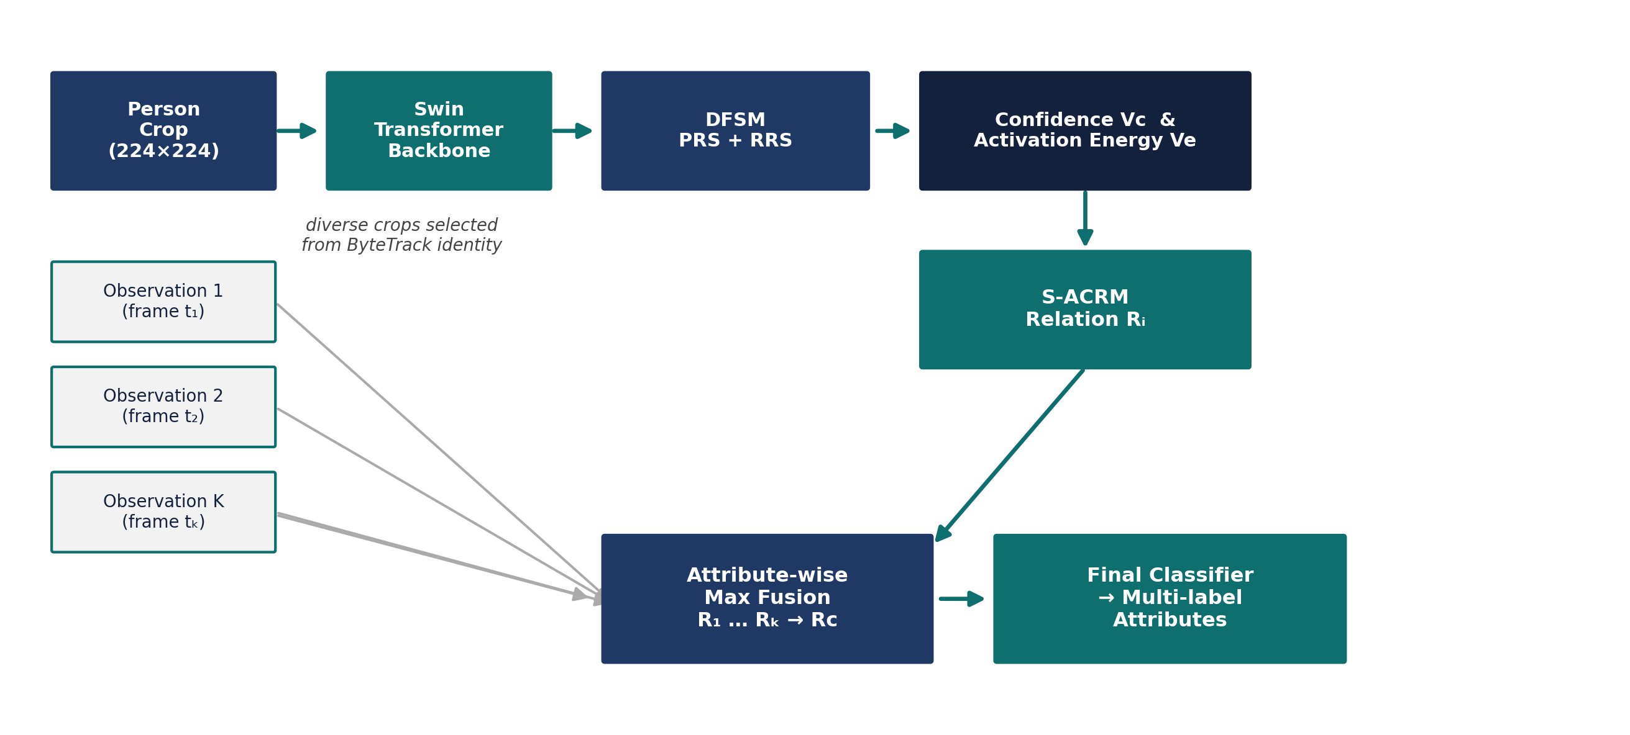
Figure 5. Attribute pipeline: from person crop to fused multi-label prediction.
If a backpack is ambiguous in one frame but clearly visible in another, the clearer observation dominates the fused decision rather than being averaged away — the mechanism behind the project's core hypothesis.

6.3 Training Configuration
Setting | Value
Input resolution | 224 × 224
Augmentation | Random flip, random crop
Optimiser | SGD, momentum 0.9, weight decay 0.0005
Learning rate | 1e-4
Batch size / epochs | 16 / 80 (starting configuration)
DFSM parameters | α = 0.9, n = 2, r = 0.25
Loss | Weighted binary cross-entropy (attribute imbalance)

7. Experimental Design and Ablations
Each pipeline component is validated independently before the full system is assembled, so that any improvement in the final result can be attributed to a specific design choice rather than the pipeline as a whole.
ID | Experiment | Validates
D1 | Pretrained vs. fine-tuned detector | Target-domain adaptation benefit
D2 | VisDrone vs. VisDrone + project footage | Real-aerial and target-domain benefit
D3 | Optional synthetic → real aerial pretraining chain | Value of synthetic pretraining
T1 | Detector + tracker identity continuity | Tracking reliability
A1 | Swin-only attribute baseline | Single-frame reference performance
A2 | PRS / RRS / PRS+RRS | Diverse-feature suppression contribution
A3 | K = 1, 2, 3, 4, 5 fused observations | Multi-observation fusion benefit
A4 | With vs. without relation fusion | Activation-confidence relation contribution
A5 | Full assembled system | Overall end-to-end performance

The single most important comparison in this design is K = 1 against K > 1: it isolates whether the tracked multi-observation mechanism adds measurable value beyond a strong single-frame attribute model, which is the central claim the project sets out to test.

7.1 Evaluation Metrics
Task | Metrics
Detection | Precision, Recall, mAP@50, mAP@50:95, FPS
Tracking | IDF1, MOTA, identity switches
Attribute recognition | Mean accuracy (mA), Accuracy, Precision, Recall, F1

8. Deliverables
The completed project produces the following artefacts:
- Final detector checkpoint and held-out detection metrics
- Person-trajectory data from the tracker
- A person-crop dataset with identity and frame metadata
- Single-frame (Swin) baseline results
- Diverse-feature-suppression ablation results
- Relation-fusion ablation results
- K = 1–5 multi-observation ablation results
- A fully annotated version of the project's 30-minute video
- A per-person attribute record in CSV/JSON format
- Qualitative examples covering small people, occlusion, viewpoint change, and clear versus ambiguous attribute cases

8.1 Per-Person Output Record
Each row of the final output corresponds to one detection and includes the following fields:
video_id | frame_id | person_id | x1 | y1 | x2 | y2 | detector_confidence | backpack | hat | upper_colour | upper_style | lower_colour | lower_style | attribute_confidence

9. Execution Plan
Stages are executed sequentially, with each stage's checkpoint or dataset validated before the next begins. No fixed calendar is imposed; each phase starts once its prerequisite is confirmed to be reliable.
Phase | Operation | Deliverable
1 | Audit footage and determine sampling rate | Candidate frame set
2 | Run pretrained detector for baseline | Baseline detections
3 | Automatic annotation with human correction | Ground-truth boxes
4 | Prepare VisDrone for training | Aerial detection dataset
5 | Optional SkyScenes mask-to-box conversion | Synthetic aerial dataset
6 | Fine-tune the detector | Final detector checkpoint
7 | Run detector + tracker | Person trajectories
8 | Select diverse per-person observations | Crop sequences
9 | Prepare attribute training data | Attribute training set
10 | Train single-frame attribute baseline | Swin baseline model
11 | Add diverse-feature suppression | DFSM ablation results
12 | Add relation fusion across observations | Multi-observation model
13 | Evaluate across K = 1–5 | Ablation evidence
14 | Run the full pipeline on the complete video | Final annotated video + CSV/JSON

10. References and Resources

10.1 Datasets
- VisDrone — github.com/VisDrone/VisDrone-Dataset
- UAV-Human — github.com/sutdcv/UAV-Human | sutdcv.github.io/uav-human-web
- SkyScenes — github.com/hoffman-group/SkyScenes | huggingface.co/datasets/hoffman-lab/SkyScenes | arxiv.org/abs/2312.06719
- PA-100K (HydraPlus-Net) — github.com/xh-liu/HydraPlus-Net
- PETA — mmlab.ie.cuhk.edu.hk/projects/PETA.html
- RAPv1/RAPv2 — github.com/valencebond/RAP-dataset
- UPAR — github.com/speckean/upar_dataset

10.2 Models and Tools
- RT-DETRv2 — huggingface.co/docs/transformers/model_doc/rt_detr_v2
- ByteTrack — github.com/FoundationVision/ByteTrack
- CVAT automatic annotation — docs.cvat.ai/docs/annotation/auto-annotation/automatic-annotation
- Ultralytics (optional annotation assistant) — docs.ultralytics.com/tasks/detect

10.3 Methodological Basis
The relation-based evidence fusion and diverse-feature suppression mechanisms in Section 6 draw on recent work in multi-observation pedestrian attribute recognition and transformer-based complementary feature discovery. Both have been adapted here for the aerial, UAV-tracked setting, in combination with the detection and tracking stages described in Sections 4 and 5.

